1.

|  |  |  |
| --- | --- | --- |
| **Activity** | **Probability of Occurrence** | **Cost** |
| A | 20% | US$ 100.000 |
| B | 50% | US$ 300.000 |
| C | 70% | US$ 50.000 |
| D | 55% | US$ 250.00 |

Based on the table, what activity should receive risk-response-planning priority?

1. А
2. B
3. C
4. D

Answer: B

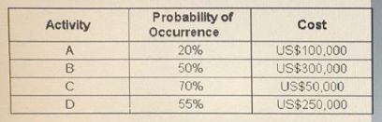2.

Based on the table, what activity should receive risk-response-planning priority?

1. A
2. B
3. C
4. D

Ans: B

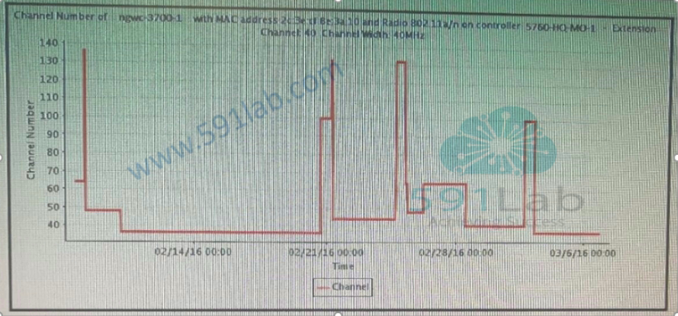3.

Refer to the exhibit. You use Cisco Prime Infrastructure to monitor a wireless network. The DCA is configured to run once daily after business hours at 19:30 to prevent channel changes that lead to a loss of wireless connectivity ED-RRM is enable. Users report that they lose their wireless connection during business hours when they work on their laptop in a certain area. Which interference will cause this issue?

1. microwave oven
2. Bluetooth link
3. WiMAX
4. BLE beacons

Answer: D

4.

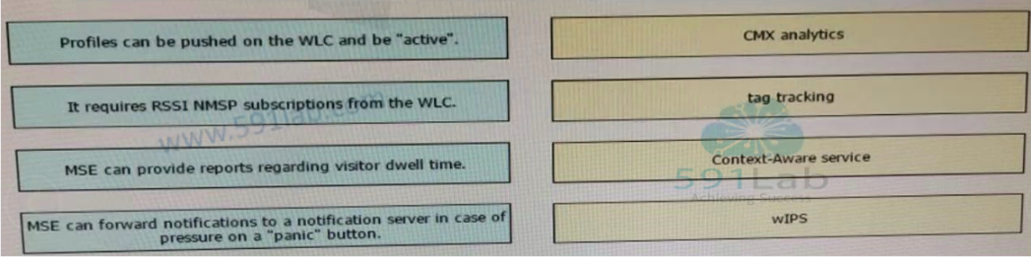Drag and drop the descriptions from the left onto the correct MSE services or features on the right.

Answer:

A → 4

B → 2

C → 1

D → 3

5.

When deploying Local Web Authentication on a Cisco WLC, you can authenticate users externally via RADIUS. Which three authentication methods are supported by the Cisco WLC to authenticate guest users to a RADIUS server? (Choose three.)

1. CHAP
2. LEAP
3. EAP-GTC
4. EAP-TLS
5. EAP-FAST
6. EAP
7. PEAP MS-CHAPv2
8. PAP
9. MD5-CHAP

Answer: AHI

6.

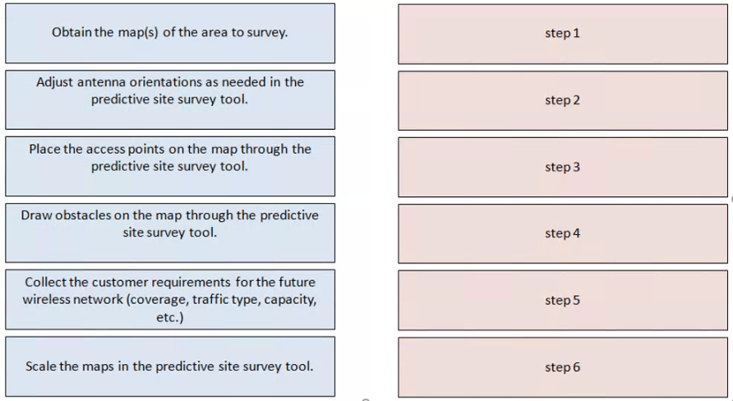Drag and drop the predictive site survey actions from the left into the correct order of operation on the right.

Answer:

From my work Experience this is the most valid step when performing Predictive Site Survey

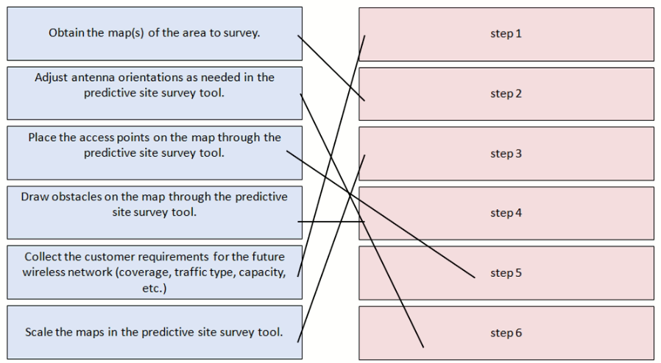

7.

Please read this scenario prior to answering the question

You have been assigned the role of chief enterprise architect within a leading professional services company that specializes in providing Outsourcing services. The company has over 20,000 professionals and works on some of the world's largest Outsourcing projects.  Outsourcing services include business processes, infrastructure, and Service Management.  The company also provides business Consulting Services.  Roughly half of its turnover comes from the private sector and half from the public sector.

With numerous service areas and a large number of diverse engagements in progress at any given time, overall engagement management within the company has become challenging.  The company has recently had a number of high-profile projects that have overrun on budget and under delivered, thereby damaging its reputation and adversely impacting its share price.

The company has established an enterprise architecture program based on the TOGAF standard, sponsored jointly by the chief executive officer and Chief Information Officer.  An architecture board has been formed comprised of IT staff executives and executives from the major surface areas and consulting practice.

The Enterprise architecture (EA) has been working with the strategic planning team to create strategic enterprise architecture to address these issues.  The EA team has defined a framework and held workshops with key stakeholders to define a set of architecture principles to govern the architecture work.  They have completed an architecture vision at a strategic level and laid out architecture definitions for the four domains.  They have set out an ambitious vision of the future of the company over a Five-year period. This will include three distinct transformations.

The CIO has made it clear that prior to the approval of the detailed implementation and migration plan, the EA team will need to assess the risks associated with the proposed architecture.  He has received concerns from some of the Vice Presidents across the company that the proposed architecture may be too ambitious and they are not sure it can produce sufficient value to warrant the risks.

Refer to the scenario

You have been asked to recommend an approach to satisfy these concerns.

Based on the TOGAF standard, which of the following is the best answer?

* Before preparing the detailed implementation and migration plan.  The EA team should review and consolidate the gap analysis results from phases B to D.  This can be used to understand the transformations that are required to achieve the proposed target architecture.  The EA team should then assess the readiness of the organization to undergo change.  Once the architecture has been assembled, it should be analyzed using a state evolution table to determine the transition architectures.
* The EA Team should bring together information about potential solutions from the appropriate sources.  Once the target architecture has been assembled, it should be analyzed using a state evolution table to determine the transition architectures. A value realization process should then be established to ensure that the concerns raised are addressed.
* The EA team should apply and interoperability analysis to evaluate any potential issues across the architecture.  This should include the development of a matrix showing the interoperability requirements. Once all the concerns have been resolved.  The EA team should finalized architecture roadmap and the implementation and migration plan.
* **The EA Team should evaluate the organizations readiness to undergo change.  This will allow the risks associated with the transformation to be identified and mitigated for.  It will also identify improvement actions to be worked into the implementation and migration plan. The business value assessment techniques should then be used to determine the business value and associated risks for the transformation.**

**the scenario locates us in phase F, migration planning "The CIO has made it clear that prior to the approval of the detailed implementation and migration plan, the EA team will need to assess the risks associated with the proposed architecture"**

**from that sentence, I understand the previous phases were done, and there is a target architecture defined.**

**risk assessment is part of this phase F**

**because it talks to "business value" as well. and that is included as part of "Prioritize the Migration Projects through the Conduct of a Cost/Benefit Assessment and Risk Validation"**

8.

Which of the following best describes the purpose of the architecture definition document?

* To ensure that architecture information is communicated to the right stakeholders at the right time
* To govern the architecture throughout its implementation process.
* To show progression of change from the baseline architecture to the Target Architecture
* To provide a high-level view of the end Architecture product
* 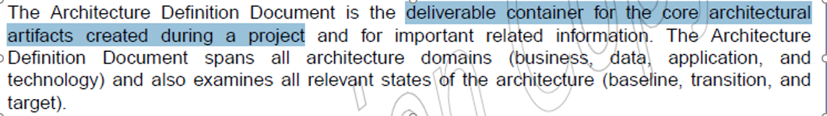**To act as a deliverable container for artifacts created during a project**

9.

A project manager is internally recruiting resources for project execution. Since the company is a matrix organization, the project manager asks the functional manager for resources. The functional manager refuses to provide the requested resources, arguing that their skills do not align with project tasks. The project manager argues that the risk is already identified and that resources will develop new skills during the project.

What should the project manager do next?

1. Ask the functional manager to engage with the human resource department to hire new external resources
2. Escalate the issue to the project sponsor, highlighting the risk of delay due to missing resources.
3. Redefine the skills required for the project to obtain the resources per the functional manager's expectations
4. Use a variable analysis to replan activities and reduce dependency on unavailable skills in the short term, then formally request the resources

Answer: C

10.

Midway through a project in a matrix organization, the project manager discovers a resource gap that requires a technical expert. The company's only technical expert is involved full-time in another project.

What should the project manager do?

1. Ask the other project manager for access to the technical expert.
2. Review the issue with the other project manager to find the best solution for both projects.
3. Inform senior management about the consequences of a delay without this resource
4. Ask two resources to learn the technology and complete the project deliverables

Answer: B

11.

Two team members are unable to move forward on an activity because they disagree about how to execute it. What should the project manager do to achieve a win-win resolution?

1. Brainstorm alternatives until a consensus is reached.
2. Emphasize areas of agreement to reach a decision.
3. Require both team members to compromise and facilitate a conclusion
4. Ask an external expert to determine the best option.

Answer: A

12.

A project manager assumes a multi-country project that is expected to provide the company with significant tax benefits. During the execution phase, the project manager encounters taxation process exceptions and changes that were not included in the project charter.

What should have been considered during project initiation to avoid this?

1. Enterprise environmental factors
2. Lessons learned
3. Project scope statement
4. Configuration management plan

Answer: A

13.

What can a project manager do to communicate the formal project announcement and relevant information to stakeholders, and then gain their commitment?

1. Create the project charter.
2. Conduct a kick-off meeting
3. Develop the communications management plan.
4. Prepare and distribute the responsible, accountable, consult, and inform (RACI) matrix.

Answer: B

14.

A marketing team's project manager is working on improving an employee engagement project. The marketing team will be creating materials, events, and messages to increase engagement

How should the project manager approach stakeholder engagement?

1. Use brainstorming to define the stakeholder engagement plan.
2. Create a power/interest grid to identify stakeholders' levels of authority
3. Classify stakeholders according to their influence on project work
4. Hold a kick-off meeting to gain employee support.

Answer: A

15.

A project is proceeding less quickly than planned, and most stakeholders complain about communication challenges. The project manager has sufficient reserves to improve communications, and the team agrees it will positively impact the project. Since approved reserves are already available, the team believes that a change request, which takes several days for approval, may not be required.

What should the project manager do?

1. Submit a change request to ensure that the process is being fulfilled and documented.
2. Immediately begin implementing the change.
3. Ask the project sponsor for approval.
4. Continue with the current communications management plan.

Answer: A

16.

The budget of a once key, long-term growth project has been cut because the company is now focusing on efficiency rather than profits. The project manager has one month to devise a way to continue the project before it is terminated.

As the project is still deemed strategic, what should the project manager do?

1. Fast track the project to align with the new budget and obtain approval of existing deliverables.
2. Provide an impact analysis of the budget cut to the project sponsor
3. Reduce manpower and other fixed costs.
4. Recommend a reduced scope that aligns with the new budget and execute change control procedures.

Answer: D

17.

Midway through a project's execution phase, the client asks to add new product features. What should the project manager do first?

1. Review the project scope with project team members and the client.
2. Obtain scope-change approval from the change control board (CCB).
3. Reject the request.
4. Assess the impact of the request on the overall project management plan.

Answer: D

18.

During a status meeting, a stakeholder requests a new requirement that was previously unidentified. What should the project manager do?

1. Deny the request.
2. Perform a risk analysis.
3. Implement the change and update the project management plan.
4. Execute the Perform Integrated Change Control process.

Answer: D